**BI Project Financial Data**

**Raw Data**

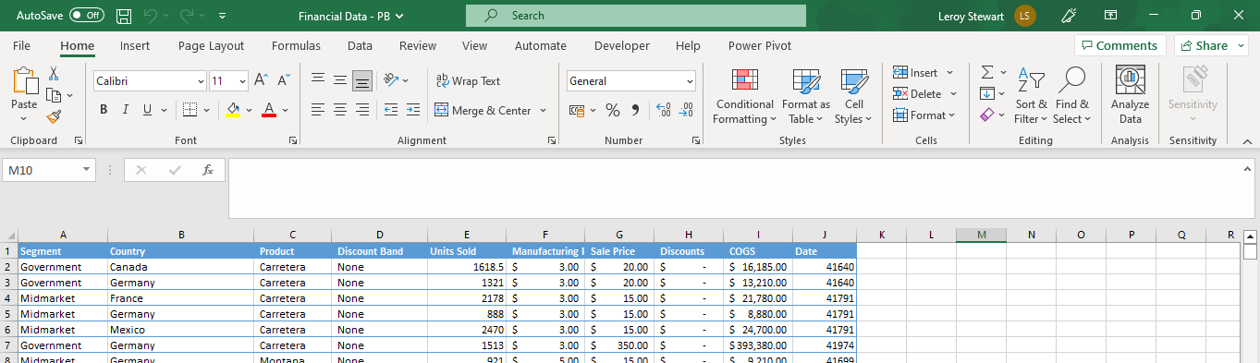

**Clean Data**

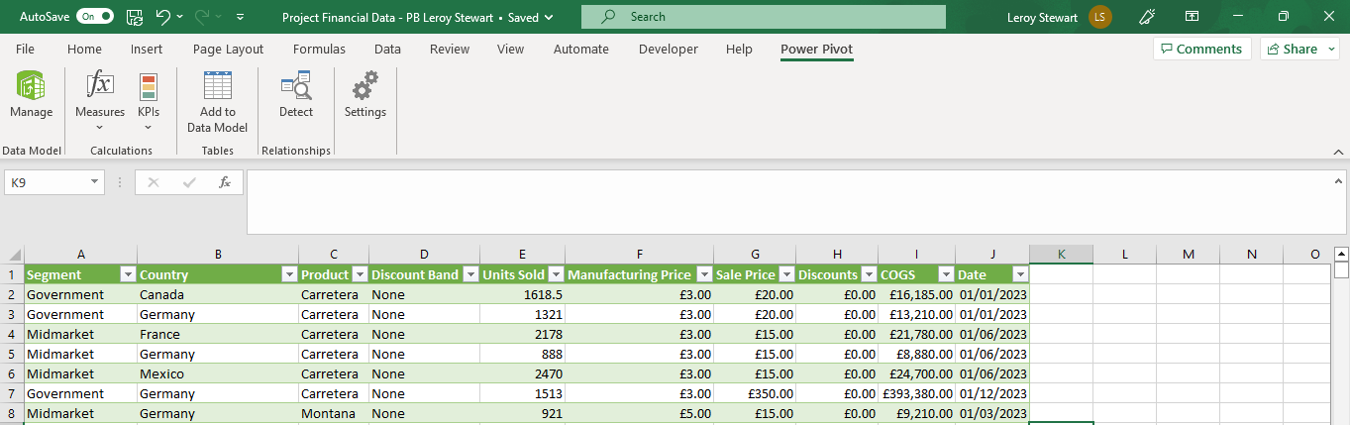

**Dax Data Model**

**BI Visuals of Data**